How To Use UltraISO Software To Create Bootable USB Flash Drive
We know that there are many free alternatives available to create to bootable Windows USB flash drive. Even one can use the Command Prompt to install Windows 8.1 from USB flash drive. But the purpose of this post is to let the UltraISO users know about the a superb functionality present in their favorite ISO burning software.
Here is how to use UltraISO software to create bootable USB drive:
Step 1: Download and install UltraISO software on your PC. Even though UltraISO is a paid software, you can download the free 30-day trial version to make your USB bootable.
Step 2: The next step is to run UltraISO trial version with admin rights. Right-click on the UltraISO software shortcut on the desktop or Start menu entry, and select Run as administrator option. If you are prompted with Register Now screen, click Continue to Try. button to use the trial version.
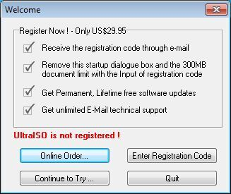
Step 3: In the home screen, click File > Open option to browse to your Windows 8.1 ISO file.
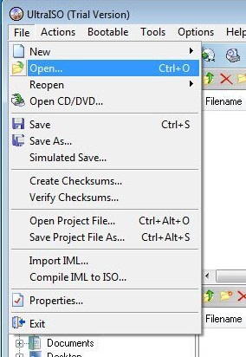
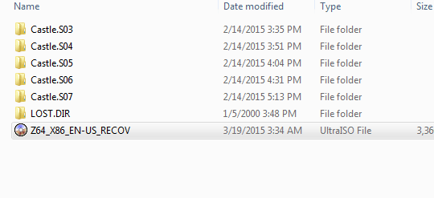
Step 4: Next, in the home screen of UltraISO, click on Bootable menu and then click Write Disk Image option to launch Write Disk Image dialog box.
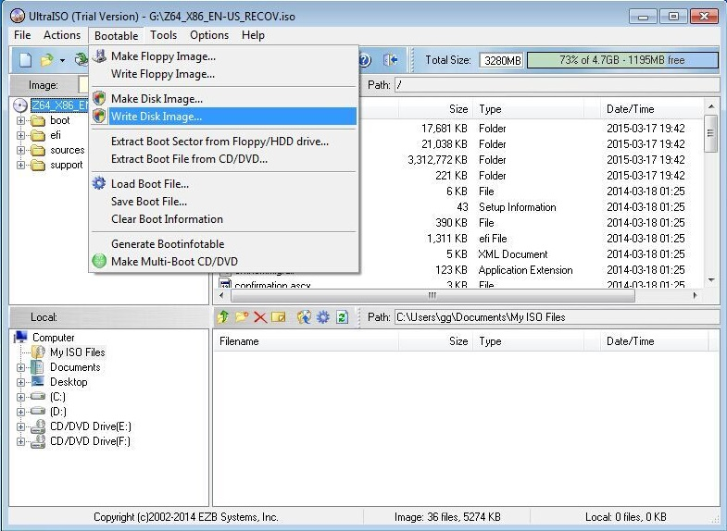
Step 5: In the Write Disk Image dialog, select the Disk Drive as your USB flash drive, select the write method as USB-HDD before hitting the Format button. It will then launch Format Removable Disk dialog, where you need to simply click Start button to begin formatting the flash drive. Please backup all data from the USB device before hitting the Format button.
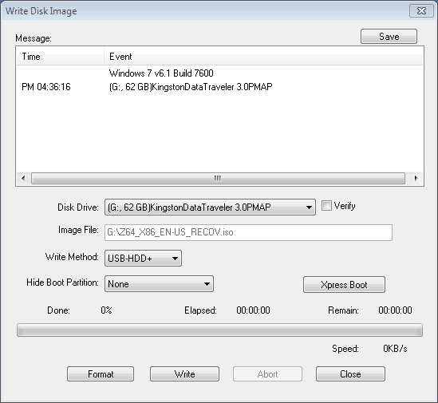
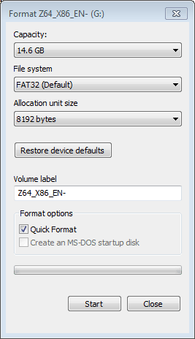
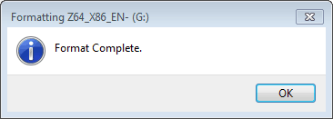
Step 6: Once the format in done, click Write button and then click Yes for the warning prompt to start the process. When the writing is finished, you will see Burn Successful message event list. Close UltraISO software and connect your USB to a machine to start installing Windows.
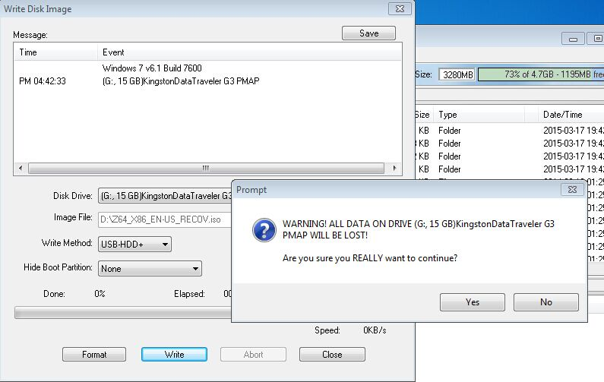
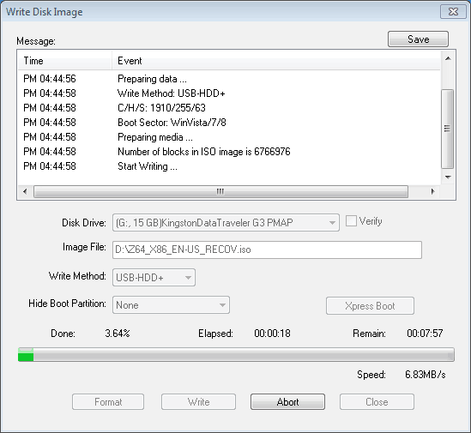
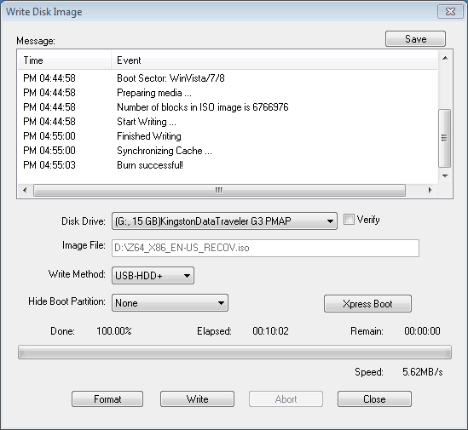
If you want to test the bootable USB before using it to install Windows, boot up the Z64 and press [F11] key to run boot menu,then select [UEFI:USB flash Driver].
